How many team member in your project
which methodology following in your project
what is last story worked on
why using typescript
why we use Angular over other like (Javascript)
What is Singleton design pattern
What other framework you know other than Angular
Which Project you like most
which project you like least
what is rxjs library
difference between SwitchMap and MergeMap
what is observable
What is nature of JavaScript (Synchronous or asynchronous)
How to make Javascript to work Asynchronous
what is dependency Injection
How to achieve localization in Angular
what is node and why we use
-----------------------------------------------------------------------
which is your previous project?
in which technologies you have worked on?
explanation about previous projects.
what kind of challenges you have faced in previous projects.
what is your favorite project among the ones you have mentioned? why?
which project you don't like among the list that you mentioned? why?
difference between promises and observable.
what code structure you followed in your previous project?
what type of methodology used in previous project?
difference between c# and JavaScript.
what is rxjs library.
use of map and tap operator in angular.
what pattern JavaScript follows asynchronous or synchronous?
difference between asynchronous and synchronous.
JavaScript is strongly typed or loosely typed?
what is singleton design pattern in angular?
what is ECMAScript?
what is the current version of angular?
write an example of pipes?
difference between pure and impure pipes.
difference between slice and splice.
why angular is better then .net application?
How many team member in your project
which methodology following in your project
what is last story worked on
why using typescript
why we use Angular over other like (Javascript)
What is Singleton design pattern
What other framework you know other than Angular
Which Project you like most
which project you like least
what is rxjs library
difference between SwitchMap and MergeMap
what is observable
What is nature of JavaScript (Synchronous or asynchronous)
How to make Javascript to work Asynchronous
what is dependency Injection
How to achieve localization in Angular
what is node and why we use

- Why to use typescript?
It helps software developers add type safety to their projects and provides features like type aliases, interfaces, abstract classes, encapsulation, inheritance, and function overloading. Overall, TypeScript makes it easier to create large and complex projects and compiles to JavaScript.

- Why we use Angular over other like (javascript) ?
Angular helps build interactive and dynamic single page applications (SPAs) through its compelling features that include templating, two-way binding, modularization, RESTful API handling, dependency injection, and AJAX handling.
Designers can use HTML as a template language and even extend HTML syntax to easily convey the components of the application. You also don’t need to rely on third-party libraries to build dynamic applications with Angular.
- What is single design pattern ?
The singleton pattern is one of the simplest design patterns. Sometimes we need to have only one instance of our class for example a single DB connection shared by multiple objects as creating a separate DB connection for every object may be costly. Similarly, there can be a single configuration manager or error manager in an application that handles all problems instead of creating multiple managers. The singleton pattern is a design pattern that restricts the instantiation of a class to one object.
https://medium.com/@JavaScript-World/javascript-singleton-design-patterns-1d11277fec01
- What other framework you know other than Angular ?

- What is rxjs library ?
Reactive programming is an asynchronous programming paradigm concerned with data streams and the propagation of change (Wikipedia). RxJS (Reactive Extensions for JavaScript) is a library for reactive programming using observables that makes it easier to compose asynchronous or callback-based code. See (RxJS Docs).
RxJS provides an implementation of the Observable type, which is needed until the type becomes part of the language and until browsers support it. The library also provides utility functions for creating and working with observables. These utility functions can be used for:
- Converting existing code for async operations into observables
- Iterating through the values in a stream
- Mapping values to different types
- Filtering streams
- Composing multiple streams

- What is the difference between switchmap and mergemap ?
https://dev.to/bhagatparwinder/map-vs-mergemap-vs-switchmap-5gee
- What is observable ?
https://stackoverflow.com/questions/51520584/what-is-observable-observer-and-subscribe-in-angular

Observables provide support for data sharing between publishers and subscribers in an angular application. It is referred to as a better technique for event handling, asynchronous programming, and handling multiple values as compared to techniques like promises.
A special feature of Observables is that it can only be accessed by a consumer who subscribes to it i.e A function for publishing values is defined, but it is not executed by the subscribed consumer (it can be any component) only via which the customer can receive notifications till the function runs or till they subscribed.
An observable can deliver multiple values of any type. The API for receiving values is the same in any condition and the setup and the logic are both handled by the observable. Rest thing is only about subscribing and unsubscribing the information required.
Observers: To handle receiving observable messages, we need an observable interface which consists of callback methods with respect to the messages by observables. Some of the basic methods are as follows:
- next: It is a handler for each message by observable, it may be called zero or more times after execution starts.
error: It is a handler for each error message. An error stops execution of the observable instance.
complete: It is a handles in which the completion of observable execution is notified.

- What is the nature of javascript ?(sync and async)

https://www.scaler.com/topics/synchronous-and-asynchronous-javascript/

- How to make javascript work async ?
https://levelup.gitconnected.com/asynchronous-javascript-3-ways-5c5434819a14

- what is dependency Injection ?
https://angular.io/guide/architecture-services

- How to achieve localization in Angular ?
import { TranslateModule, TranslateLoader, MissingTranslationHandler, MissingTranslationHandlerParams } from '@ngx-translate/core';

/**
* AoT requires an exported function for factories
*/
export function HttpLoaderFactory(http: HttpClient) {
/**
* Update i18nUrl and set it for loading translations
*/
let langApiUrl;
if (GLOBAL_CONFIG.PRODUCTION) {
langApiUrl = window['CONFIG']['apiUrl']
.replace('{{api_module_context_path}}', 'i18n/v1')
+ 'apps/enterprise-ui/locales/';
return new TcTranslateService().loadTranslation(http, langApiUrl);
} else {
langApiUrl = window['CONFIG']['apiUrl']
.replace('{{api_module_context_path}}', 'i18n/v1')
+ 'apps/enterprise-ui/locales/';
return new TcTranslateService().loadTranslation(http, langApiUrl);
}
}

/**
* AoT requires an exported class for missing translations
*/
export class ReservationsMissingTranslationHandler implements MissingTranslationHandler {
/**
* returns english keys from local JSON if API is unavailable
* @param params: MissingTranslationHandlerParams
*/
enRef: En;
constructor() {
this.enRef = new En();
}
handle(params: MissingTranslationHandlerParams): string {
if (params.key && this.enRef.translations[params.key]) {
if (params.interpolateParams) {
let keyString = this.enRef.translations[params.key];
const matchStringArr = (keyString.match(/{{[a-zA-Z\s\d#]+}}/g) || []);
for (const item of matchStringArr) {
const key: string = item.substring(2, item.indexOf('}}'));
const evaluatedVal: string = (params.interpolateParams[key]) ? params.interpolateParams[key] : item;
keyString = keyString.replace(item, evaluatedVal);
}
return keyString;
}
}
return this.enRef.translations[params.key];
}
}

TranslateModule.forRoot({
loader: {
provide: TranslateLoader,
useFactory: HttpLoaderFactory,
deps: [HttpClient]
},
missingTranslationHandler: {
provide: MissingTranslationHandler,
useClass: ReservationsMissingTranslationHandler,
deps: [HttpClient]
}
})

- What is nodeJs and why we use ?
https://www.simform.com/blog/best-nodejs-frameworks/

Is Node.js a Framework?
There is a longstanding debate about whether Node.js is a framework. Well more often than not, we do refer to it as one. However, Node.js is actually a JavaScript runtime environment — a platform to execute JavaScript codes on the server-side and make it portable. In layman’s terms, a runtime environment is where developers run a program.
In contrast, frameworks are used to build functions. Many developers have written frameworks for Node.js like Express.js, Meteor.js, and other tools to create unique capabilities for Node.js apps offering convenience to software engineers.

- What is the difference between promises and observable?

https://www.c-sharpcorner.com/article/observable-and-promise-in-angular/#:~:text=Observable%20can%20emit%20multiple%20values,will%20execute%20immediately%20on%20creation.

- Difference between js and c#
https://www.geeksforgeeks.org/difference-between-javascript-and-c-sharp/

- Usage of map and tap
https://blog.devgenius.io/typescript-rxjs-tap-vs-map-keyword-ac0c0b4a56f3
When to use tap?
Use tap for debug and observe the result data as is in console, without any transformation of the stream.
this.myService
.calculate(param1, param2).pipe(
take(1),
tap(object => console.log(object)),
map(object => object.name),
filter(name => name.endsWith("ltd")),
tap(name => console.log(name))
)
.subscribe(result => {
// notify client
});

- What is ECMA script ?
ECMAScript is a scripting language specification on which JavaScript is based. Ecma International is in charge of standardizing ECMAScript.

https://www.geeksforgeeks.org/introduction-to-es6/

but latest one is ES13.
https://www.codingbeautydev.com/blog/es13-javascript-features#:~:text=Static%20Class%20Fields%20and%20Static,access%20them%20using%20this.constructor%20.

- What is the latest version of angular ?
https://blog.angular.io/angular-v16-is-here-4d7a28ec680d

- What is pure and impure pipe ?
https://www.geeksforgeeks.org/explain-pure-and-impure-pipe-in-angular/
- Difference between slice and splice ?
https://www.w3schools.com/js/js_array_methods.asp

- Why angular is better than .net ?
https://imaginet.com/2020/reasons-use-angular-instead-asp-net-mvc-razor/#:~:text=Single%2Dpage%20applications%2C%20and%20Angular,support%20that%20is%20continually%20growing.

- Other framework you know ?
Need to check for react and angularjs

What is zone.js and runoutsideAngular ?
https://angular.io/guide/change-detection-zone-pollution

what is ngrx ?
https://www.workingsoftware.dev/what-is-ngrx-and-why-is-it-used-in-angular/

different type of design pattern ?

https://www.scaler.com/topics/design-patterns/types-of-design-pattern/

Essentially, software design patterns are solutions of the design level of a software that are created for repetitive problems that software engineers come across often. Design patterns are not code, but instead are like descriptions on tackling certain software problems and designing a solution. Design patterns are, in layman terms, walkthroughs of recurring problems that were worth writing down. They do not suggest a direct solution implementation for the software problem at hand, but are an outline of a structure that could be used as per the needs of the problem.
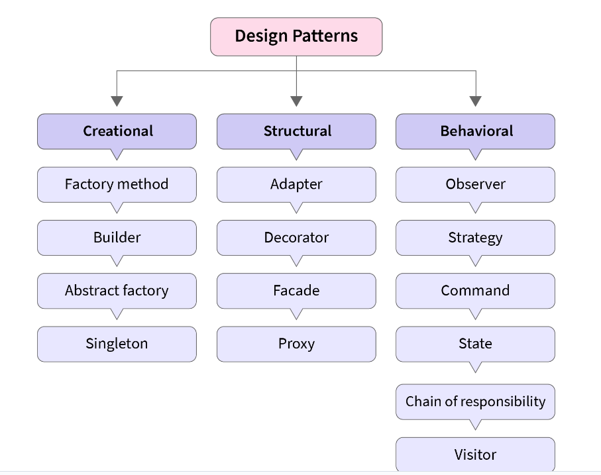

1. Creational patterns
As the name suggests, creational patterns have a lot to do with creation of objects. These patterns are designed for the instantiation of classes. Creating the objects required in the conventional format may result in additional complexity to the software design or even design problems. Creational design patterns solve this problem by controlling the object creation.
When should you use creational patterns for your software design problem? Creational patterns are most useful when instances of multiple different classes are available. To be more precise, if your software leverages polymorphism, and requires to select between various classes at runtime rather than at compile time.
Some of the creational design patterns are - Abstract Factory, Builder, Factory Method, Object Pool, Prototype, and Singleton.
- Abstract Factory: Instantiates various families of classes
- Builder: Separates the object construction from it's representations
- Factory Method: Instantiates different derived classes
- Object Pool: Used when initialization cost of class is high
- Prototype: Used when time taken to create object is large and costly. Objects are created with existing object itself.
- Singleton: Useful when coordination of actions across the system can be done by exactly one object.
Let's take an example of the singleton design pattern.

Animated Css need to check

Need to check angular jasmine karma related stuff

Difference between for….in and for……of

For in suitable for the object iteration

Both for..in and for..of are looping constructs which are used to iterate over data structures. The only difference between them is the entities they iterate over:
- for..in iterates over all enumerable property keys of an object
- for..of iterates over the values of an iterable object. Examples of iterable objects are arrays, strings, and NodeLists.
Ex.
const array1 = ['a', 'b', 'c'];
for (const element of array1) {
console.log(element);
}
o/p: > "a"
> "b"
> "c"

const array1 = ['a', 'b', 'c'];
for (const element in array1) {
console.log(element);
}
o/p: > "0"
> "1"
> "2"
----------------------------------
const object = { a: 1, b: 2, c: 3 };
for (const property in object) {
console.log(`${property}: ${object[property]}`);
}

o/p: > "a: 1"
> "b: 2"
> "c: 3"

ForEach() method – takes callback function
The forEach() method calls a function for each element in an array.
The forEach() method is not executed for empty elements.
let sum = 0;
const numbers = [65, 44, 12, 4];
numbers.forEach(myFunction);
function myFunction(item) {
sum += item;
}
o/p: 125

